**Greedy algorithm**



* First we choose the first best brick, then the second best brick… so on.
* According to the definition, the greedy algorithm is an algorithmic paradigm that will solve a solution piece by piece.
* The next important property of the algorithm is it chooses the next piece that offer the most obvious

and immediate benefit



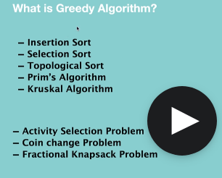

**Known greedy algorithms**

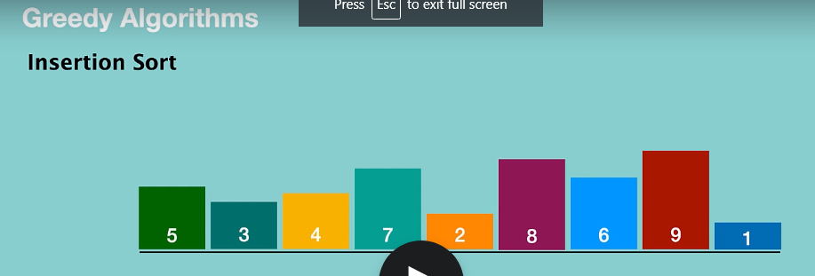

The first thing that we are going to do over here, we divide this array into two parts which are sorted and unsorted array.

We take the first element and put it in its perfect location in sorted array.

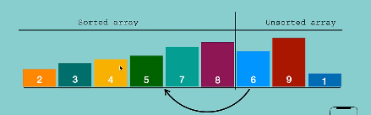

So by putting these elements in its perfect location, we kept our local solution as optimal.

So at the end, this local solution leads us to optimum global solution.

**Selection sort**

* And in each iteration we are finding the minimum element from unsorted array and put it sorted array.

**Topological sort**

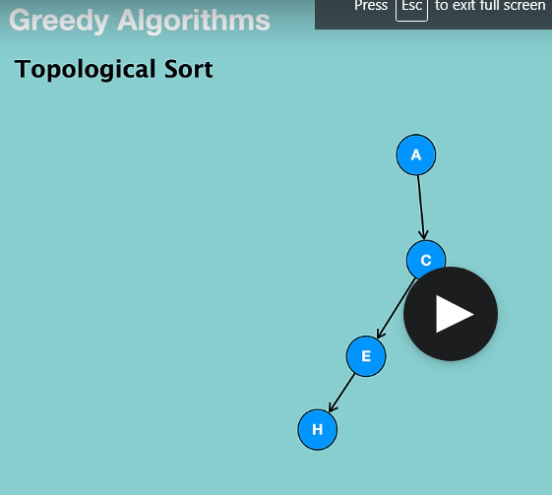

If the node doesn’t lead to local optimum solution, we defer the push operation in the stack.

No element depends on “H”. “H” is the best solution. So,it is pushed into the stack.

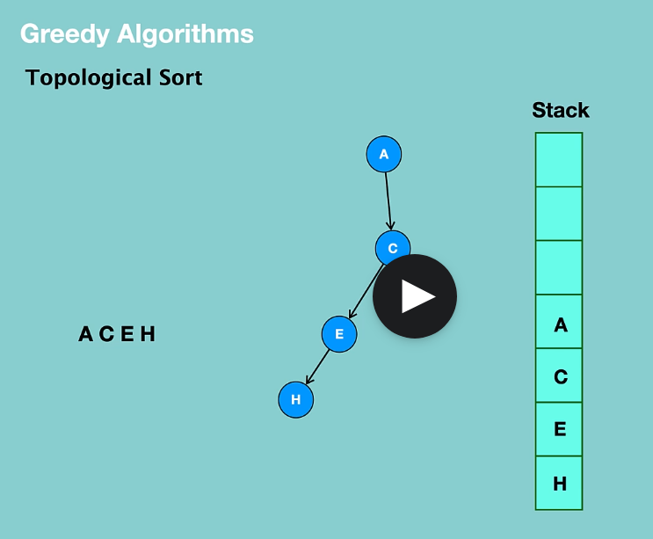

* **Prim’s algorithm**

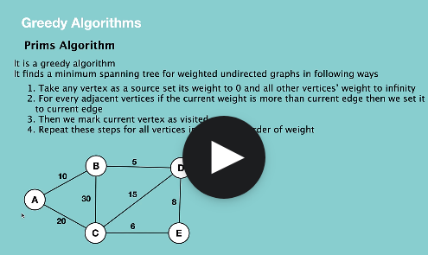

Now, let's say we have a graph like this and we start from A.

As a first step, we set A to 0 and all other nodes to infinity.

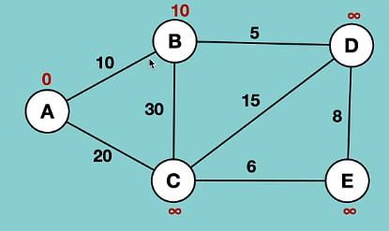

* The local optimum solution is “B”. Since B’s cost is less than 20.
* 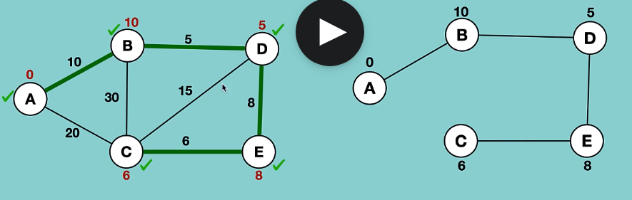

**Kruskal’s algorithm**

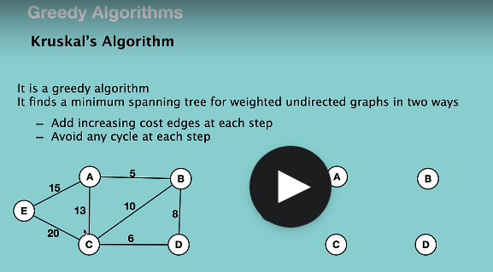

First thing that we are going to do here is to find the minimum edge.

i.e. between A and B = 5

Then find next minimum edge which is between C and D.

Next edge is BD.

Next edge is BC. But it causes cycle. So, we ignore it

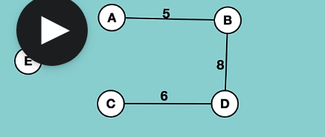

Solution:

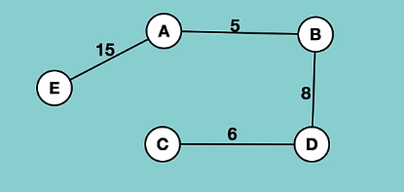

**Activity selection Problem**

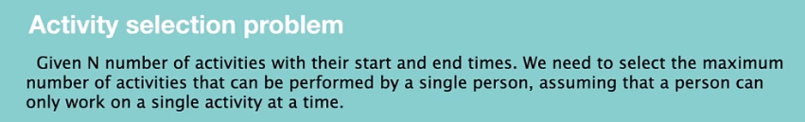

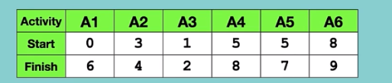

So one approach to improve this solution is we can sort activities based on finish time and then we can perform activities.

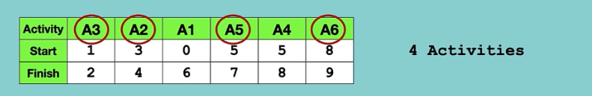

We took A3 which is the best solution at that time and then we took A2.

* 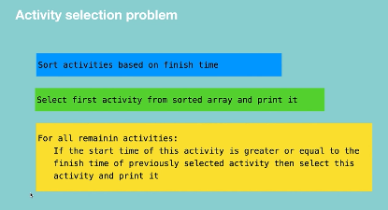

**Coding in Java**

**public** **class** Activity {

**private** String name;

**private** **int** startTime;

**private** **int** endTime;

**public** Activity(String name, **int** startTime, **int** endTime) {

**this**.setName(name);

**this**.setStartTime(startTime);

**this**.setEndTime(endTime);

}

**public** String getName() {

**return** name;

}

**public** **void** setName(String name) {

**this**.name = name;

}

**public** **int** getStartTime() {

**return** startTime;

}

**public** **void** setStartTime(**int** startTime) {

**this**.startTime = startTime;

}

**public** **int** getEndTime() {

**return** endTime;

}

**public** **void** setEndTime(**int** endTime) {

**this**.endTime = endTime;

}

**public** String toString() {

**return** "Activity: "+name+" start time: "+startTime+" end time: "+endTime;

}

}

**import** java.util.*;

**public** **class** ActivitySelection {

**static** **void** activitySelection(ArrayList<Activity> activities) {

Comparator<Activity> finishTimeComparator = **new** Comparator<Activity>() {

@Override

**public** **int** compare(Activity o1, Activity o2) {

**return** o1.getEndTime()-o2.getEndTime();

}

};

Collections.*sort*(activities, finishTimeComparator);

Activity previousActivity= activities.get(0);

System.***out***.println("recommended schedule: "+ activities.get(0));

**for**(**int** i=1;i<activities.size();i++) {

Activity activity= activities.get(i);

**if**(activity.getStartTime()>=previousActivity.getEndTime()) {

System.***out***.println("recommended schedule: "+ activity);

previousActivity=activity;

}

}

}

}

Main.java

**import** java.util.*;

**public** **class** Main {

**public** **static** **void** main(String args[]) {

ArrayList<Activity> activityList = **new** ArrayList<>();

activityList.add(**new** Activity("A1",0,6));

activityList.add(**new** Activity("A2",3,4));

activityList.add(**new** Activity("A3",1,2));

activityList.add(**new** Activity("A4",5,8));

activityList.add(**new** Activity("A5",5,7));

activityList.add(**new** Activity("A6",8,9));

ActivitySelection.*activitySelection*(activityList);

}

}

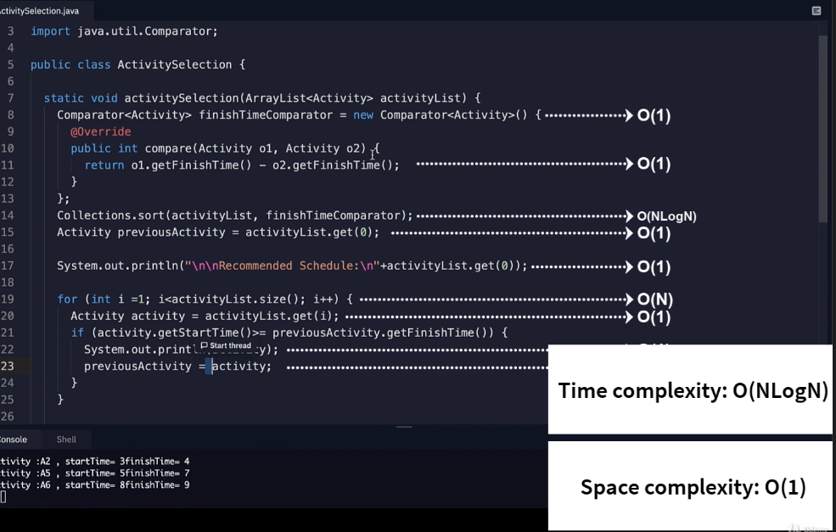

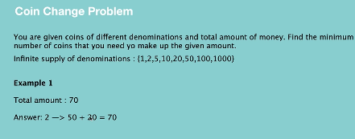



Eg: If total amount is 2035, we take the maximum number from the set i.e. 1000 and compare with 2035.

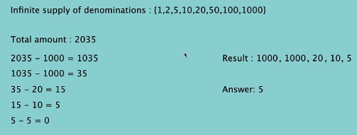

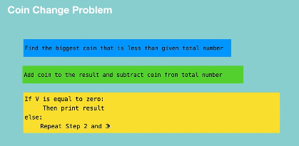

**package** CoinChange;

**import** java.util.Arrays;

**public** **class** CoinChangeProblem {

**static** **void** coinChangeProblem(**int**[] coins, **int** N) {

Arrays.*sort*(coins);

**int** index=coins.length-1;

**while**(**true**) {

**int** coinValue=coins[index];

index--;

**int** maxAmount= (N/coinValue)*coinValue;

**if**(maxAmount>0) {

System.***out***.println("coin value "+coinValue+" taken count: "+N/coinValue);

N=N-maxAmount;

}

**if**(N==0) {

**break**;

}

}

}

}

Main.java

**package** CoinChange;

**import** java.util.Arrays;

**public** **class** Main {

**public** **static** **void** main(String args[]) {

**int**[] coins= {1,2,5,10,20,50,100,1000};

**int** amount=2035;

System.***out***.println("Coins available: "+Arrays.*toString*(coins));

System.***out***.println("Target amount: "+amount);

CoinChangeProblem.*coinChangeProblem*(coins, amount);

}

}

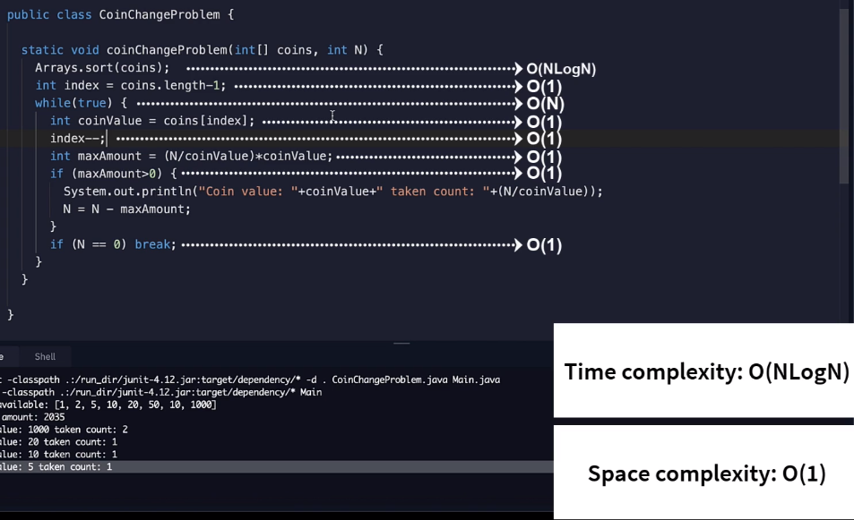

**Fractional Knapsack problem**

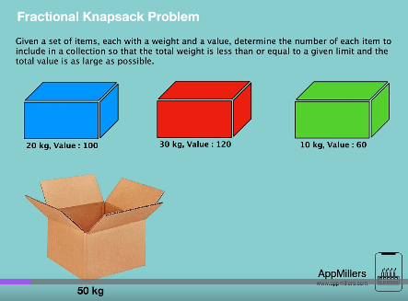

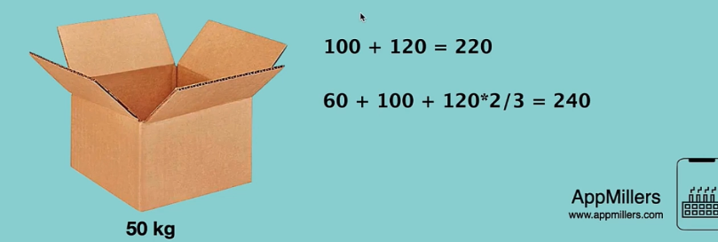

1]Calculate the value of each kg: i.e. 100/20= 5 [value=5 for 1 kg]

120/30=4

60/10=6

2] Order each box in descending order based on density.

6,5,4

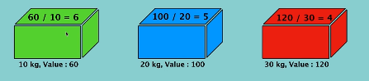

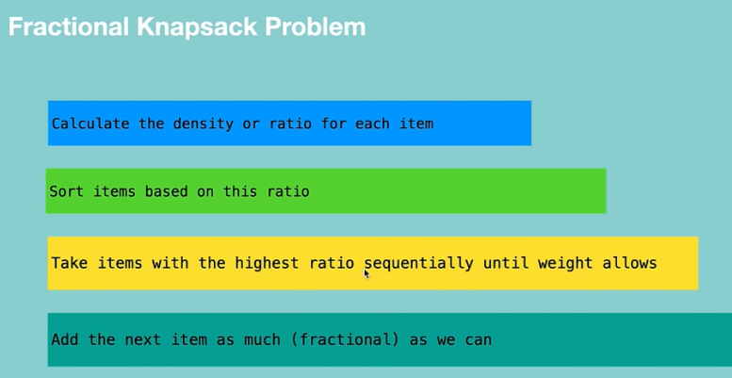

**Code:**

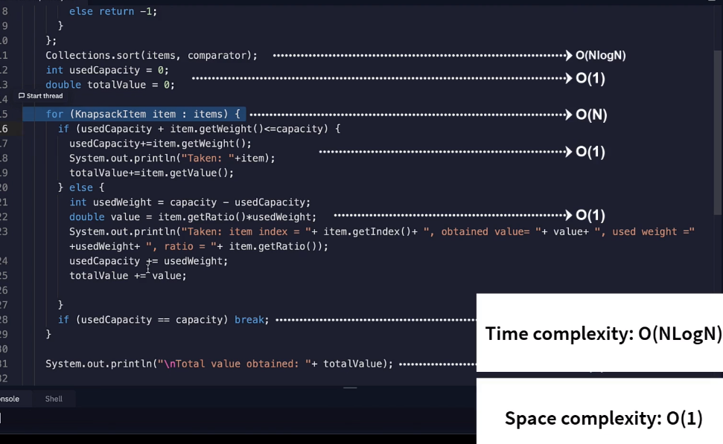

**package** FractionalKnapsack;

**public** **class** KnapsackItem {

**private** **int** index;

**private** **int** value;

**private** **int** weight;

**private** **double** ratio;

**public** KnapsackItem(**int** index, **int** value, **int** weight) {

**this**.setIndex(index);

**this**.setValue(value);

**this**.setWeight(weight);

ratio= (**double**)value/weight;

}

**public** **int** getIndex() {

**return** index;

}

**public** **void** setIndex(**int** index) {

**this**.index = index;

}

**public** **int** getValue() {

**return** value;

}

**public** **void** setValue(**int** value) {

**this**.value = value;

}

**public** **int** getWeight() {

**return** weight;

}

**public** **void** setWeight(**int** weight) {

**this**.weight = weight;

}

**public** **double** getRatio() {

**return** ratio;

}

**public** **void** setRatio(**double** ratio) {

**this**.ratio = ratio;

}

**public** String toString() {

**return** "item index= "+index+" value= "+value+" weight= "+weight+" ratio= "+ratio;

}

}

**package** FractionalKnapsack;

**import** java.util.*;

**public** **class** FractionalKnapsack {

**static** **void** knapsack(ArrayList<KnapsackItem> items, **int** capacity) {

Comparator<KnapsackItem> comparator=**new** Comparator<>() {

@Override

**public** **int** compare(KnapsackItem o1, KnapsackItem o2) {

**if**(o2.getRatio()>o1.getRatio())

**return** 1;

**else**

**return** -1;

}

};

Collections.*sort*(items, comparator);

**int** usedCapacity=0;

**double** totalValue=0;

**for**(KnapsackItem item:items) {

**if**(usedCapacity+item.getWeight()<=capacity) {

usedCapacity+=item.getWeight();

System.***out***.println("taken "+item);

totalValue+=item.getValue();

}

**else** {

**int** usedWeight= capacity-usedCapacity;

**double** value=item.getRatio()*usedWeight;

System.***out***.println("taken from index: "+item.getIndex()+" obtained value: "+value+"used weight "+usedWeight+"used ratio "+item.getRatio());

usedCapacity+=usedWeight;

totalValue+=value;

}

**if**(usedCapacity==capacity) {

**break**;

}

}

System.***out***.println("totalvalue obtained "+totalValue);

}

}

**package** FractionalKnapsack;

**import** java.util.ArrayList;

**public** **class** Main {

**public** **static** **void** main(String args[]) {

ArrayList<KnapsackItem> items=**new** ArrayList<>();

**int** value[] = {100,120,60};

**int**[] weight= {20,30,10};

**int** capacity=50;

**for**(**int** i=0;i<value.length;i++) {

items.add(**new** KnapsackItem(i+1, value[i], weight[i]));

}

FractionalKnapsack.*knapsack*(items, capacity);

}

}

**Dynamic programming**

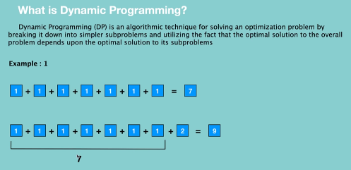

We remember the problems answer. And when we encounter the same problem next time, instead of solving it, we simply use the answer that we got before.

And this increase the efficiency of algorithm.

But in case of divide and conquer algorithm, we are calculating these sub problems again and again.

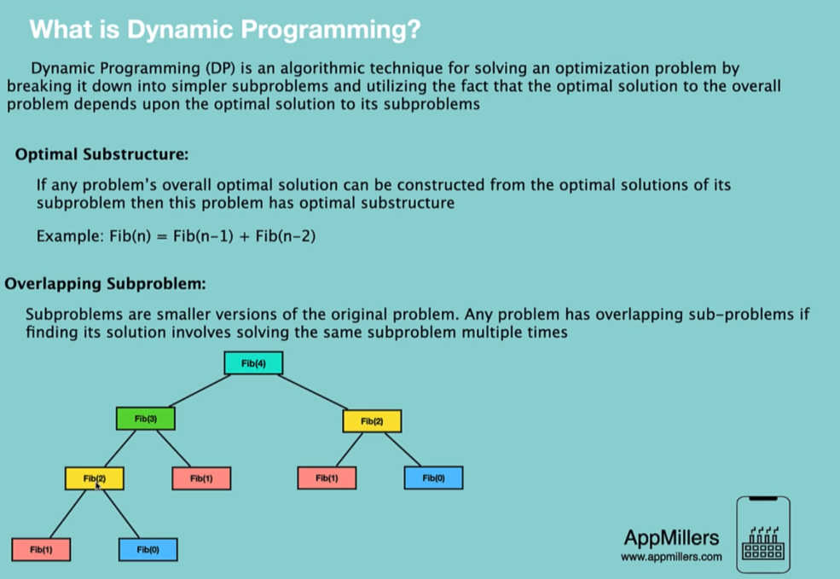

**Top down with Memoization**



The divide and conquer approach has exponential time complexity which makes it time inefficient.

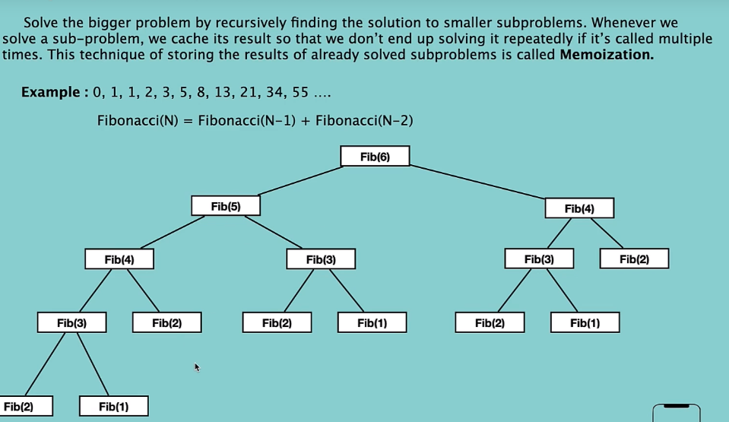

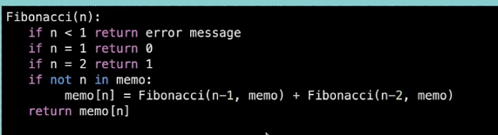

We check if the fibanacci was calculated earlier. If not, store the value of sub problem in the array.

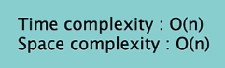

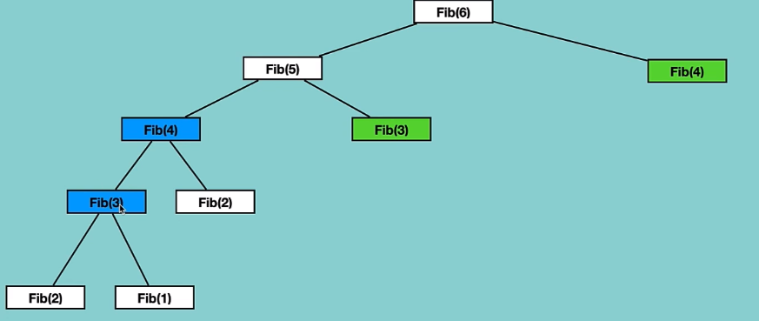

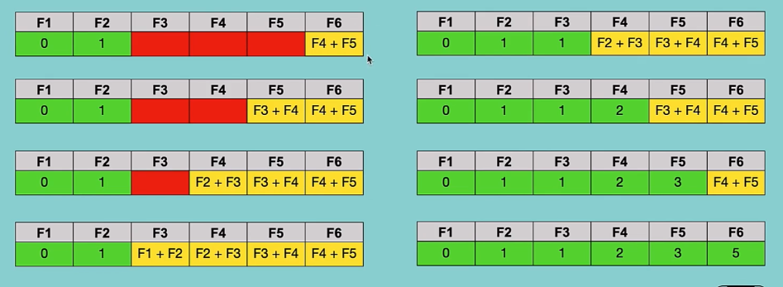

So by using top down method of dynamic programming, we can easily increase the efficiency of some divide and conquer approach problems.

Code:

**package** Fibannacci;

**import** java.util.HashMap;

**public** **class** Main {

**public** **static** **void** main(String args[]) {

HashMap<Integer,Integer> memo=**new** HashMap<>();

System.***out***.println(*fibMemo*(6,memo));

}

**public** **static** **int** fibMemo(**int** n, HashMap<Integer,Integer> memo) {

**if**(n==1) {

**return** 0;

}

**if**(n==2) {

**return** 1;

}

**if**(!memo.containsKey(n)) {

memo.put(n,*fibMemo*(n-1,memo)+*fibMemo*(n-2,memo));

}

**return** memo.get(n);

}

}

**Bottom Up with tabulation**



Recap of top-down approach

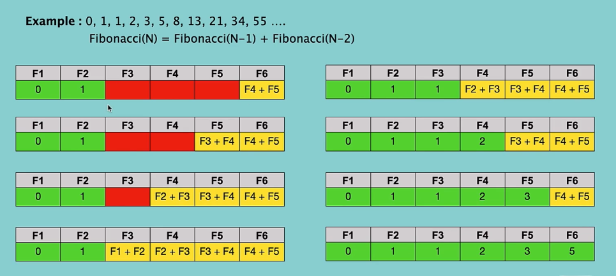

Bottom up approach

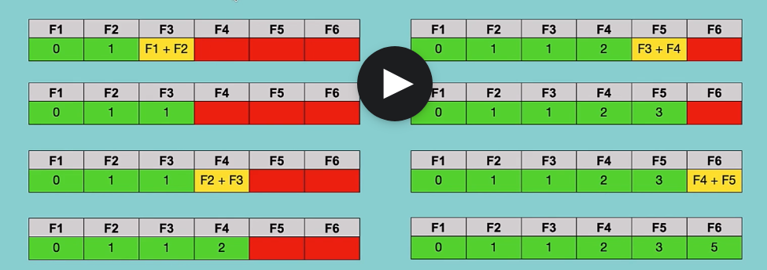

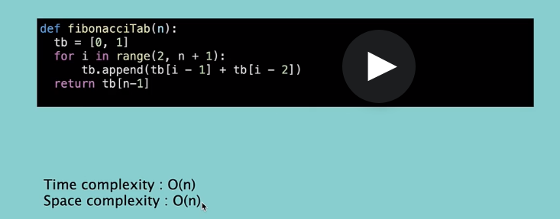

**public** **static** **int** fibTab(**int** n) {

ArrayList<Integer> tb=**new** ArrayList<>();

tb.add(0);

tb.add(1);

**for**(**int** i=2;i<=n-1;i++) {

**int** n1=tb.get(i-1);

**int** n2=tb.get(i-2);

tb.add(n1+n2);

}

**return** tb.get(n-1);

}

**Top down vs Bottom up**

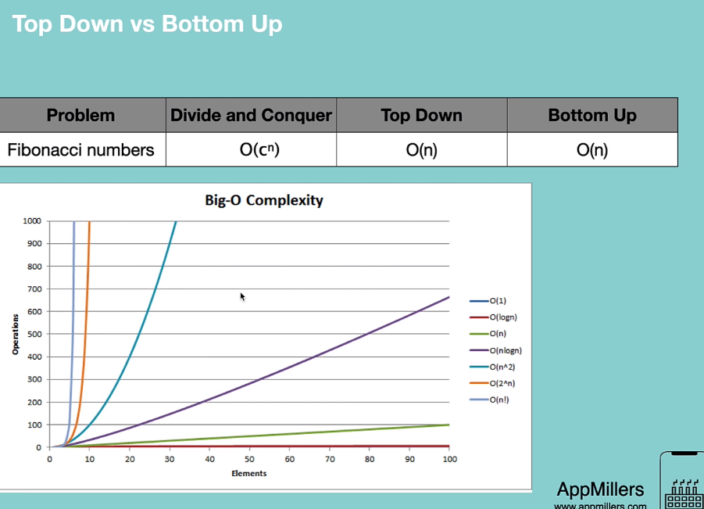

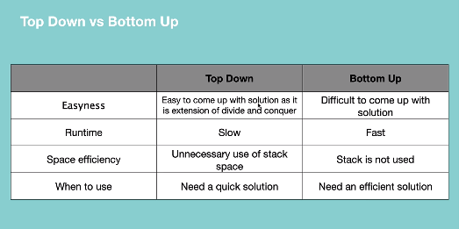

**Is merge sort dynamic programming?**



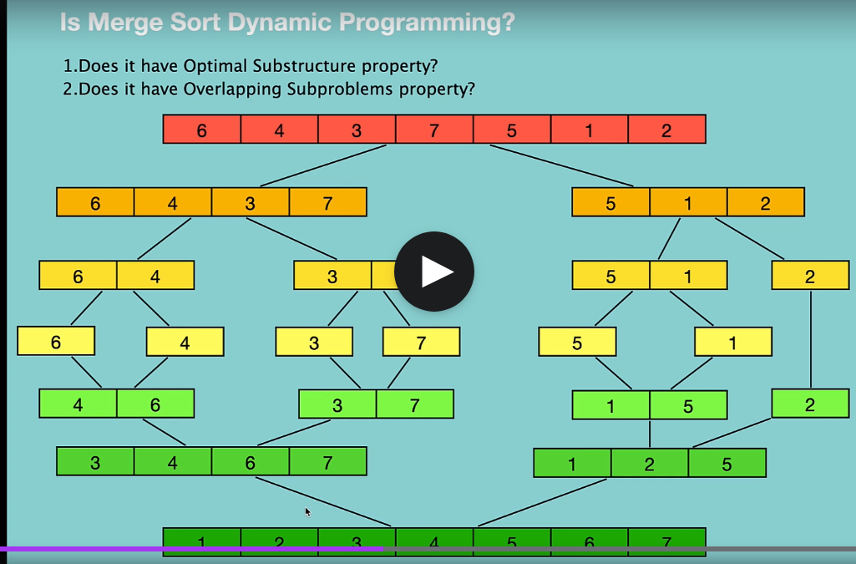

1]yes

2] We can clearly see that overlapping problems property is not here.

This means that merge sort problem can be solved by divide and conquer approach.

**Dynamic programming [Number factor]**

* Dynamic programming is an optimized version of divide and conquer.
* 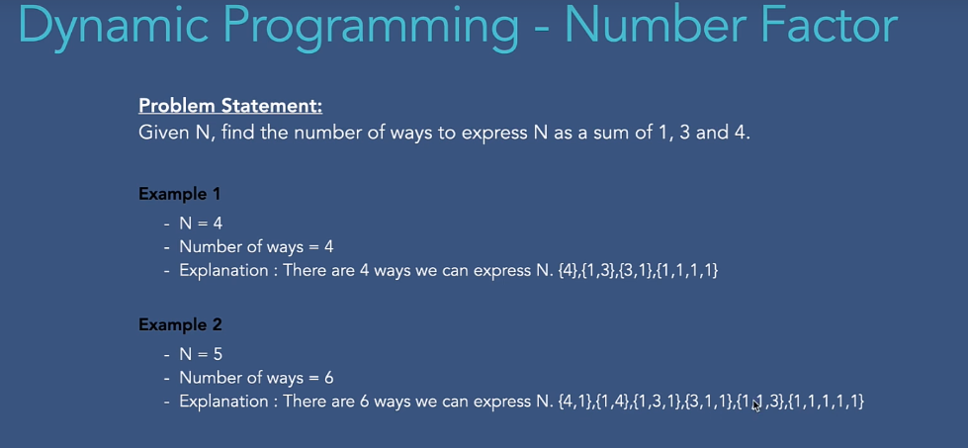

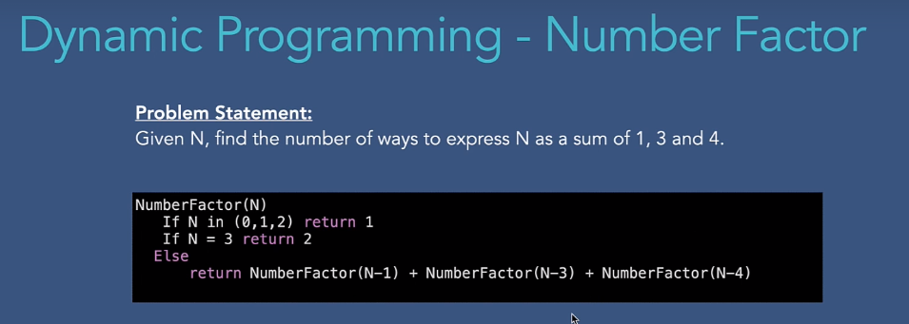

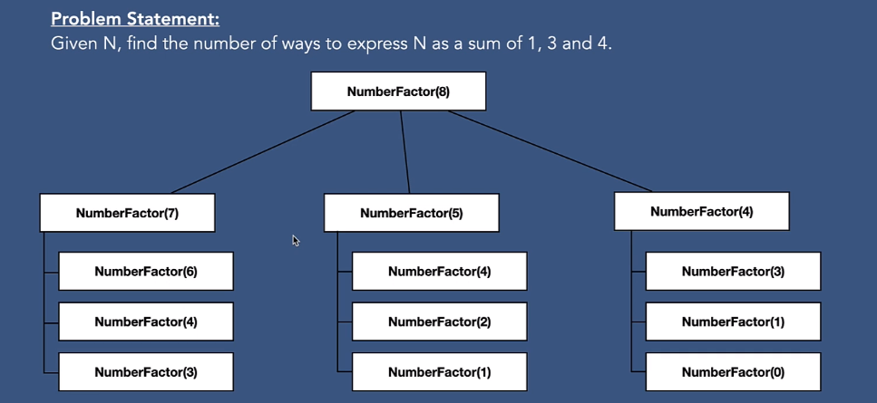

Here, we have overlapping sub-problem property.

Top – down approach

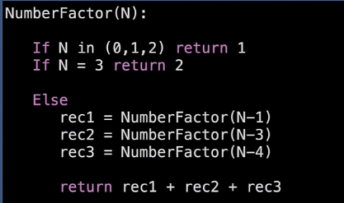

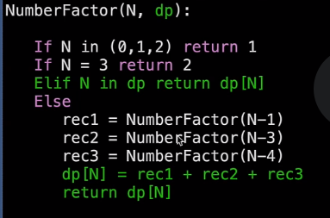

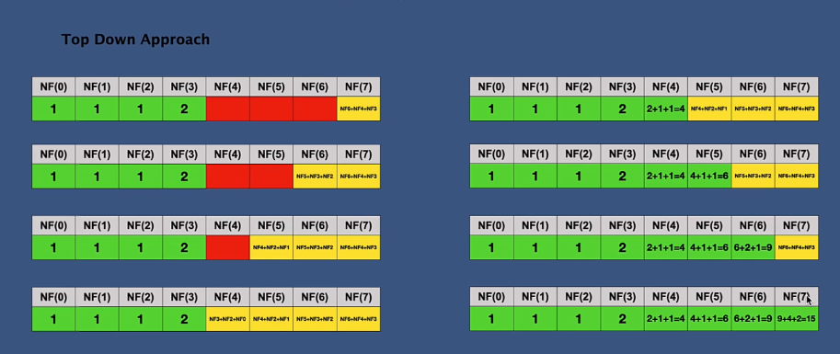

**Bottom- up approach**

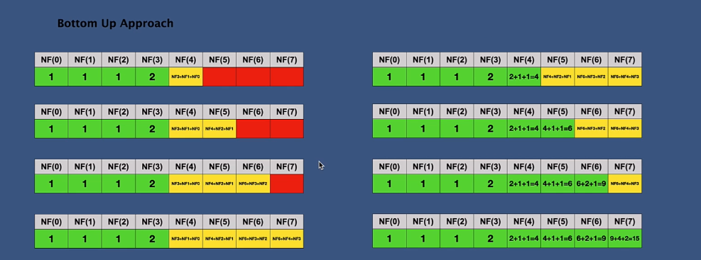

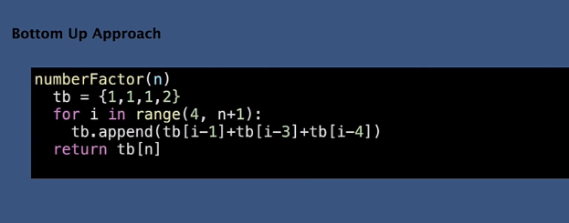

**Number factor: top down and bottom up approach**

**public** **class** NumberFactor {

**private** **static** **int** waysToGetNTopDown(**int**[] dp, **int** n) {

**if**(n==0||n==1||n==2)

**return** 1;

**else** **if**(n==3)

**return** 2;

**if**(dp[n]==0) {

**int** sub1=*waysToGetNTopDown*(dp,n-1);

**int** sub2=*waysToGetNTopDown*(dp,n-3);

**int** sub3=*waysToGetNTopDown*(dp,n-4);

dp[n]=sub1+sub2+sub3;

}

**return** dp[n];

}

**public** **static** **int** waysToGetNTopDown(**int** n) {

**int**[] dp=**new** **int**[n+1];

**return** *waysToGetNTopDown*(dp,n);

}

//bottom up

**public** **static** **void** main(String args[]) {

System.***out***.println(*waysToGetNTopDown*(5));;

}

}

**Bottom-up approach**

**public** **static** **int** waysToGetNBottomUp(**int** n) {

**int**[] dp=**new** **int**[n+1];

dp[0]=dp[1]=dp[2]=1;

dp[3]=2;

**for**(**int** i=4;i<=n;i++) {

dp[i]=dp[i-1]+dp[i-3]+dp[i-4];

}

**return** dp[n];

}

**House robber problem using dynamic programming**

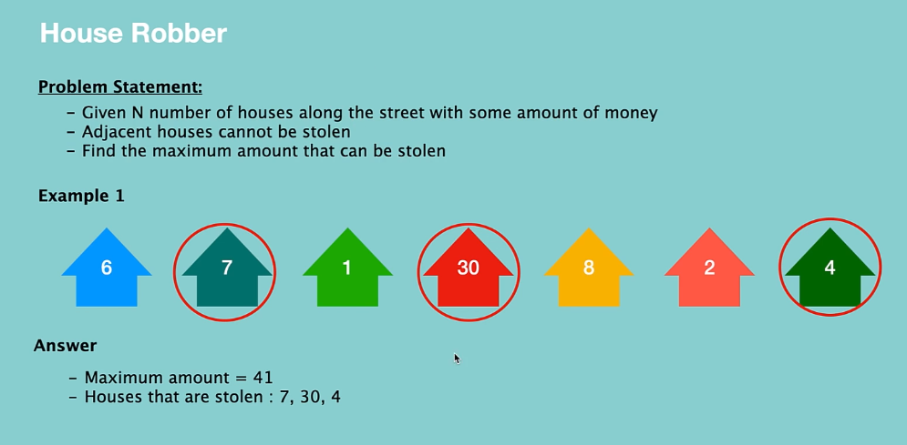

We have 2 options… skipping the first house or stealing from the first house.

After finding answers for these 2 problems, we are calculating the maximum of the 2 options.

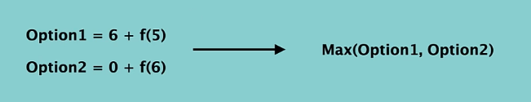

--------------------------------------------------------------------

**Divide and Conquer**

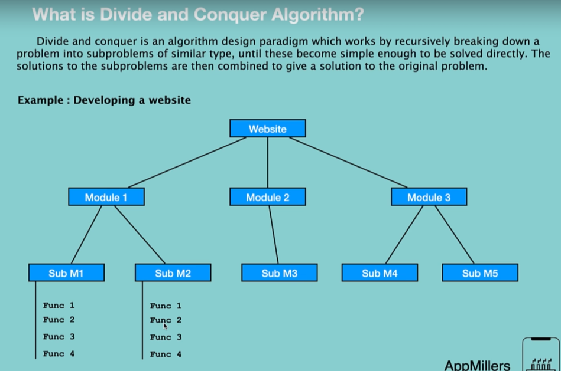



**Common divide and conquer algorithms**

**1]Merge sort**

**2] Quick sort**

**Solve Fibonacci series using divide and conquer**

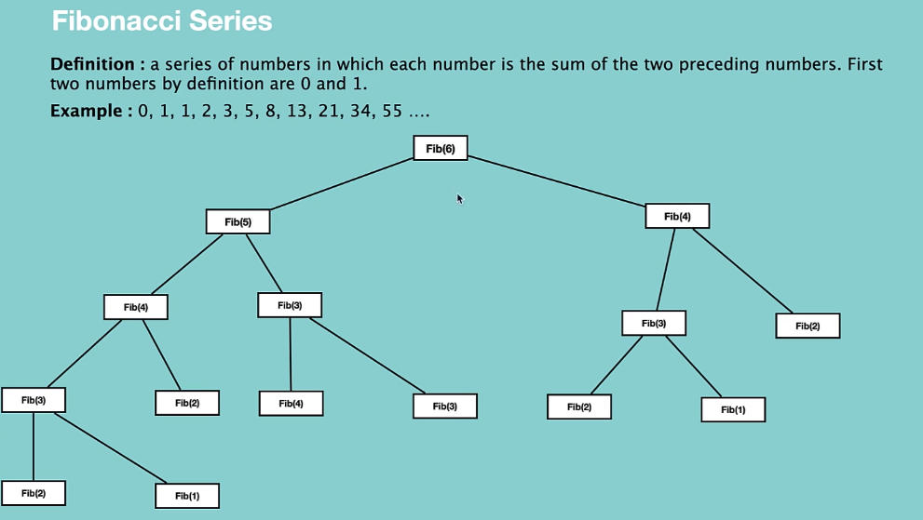

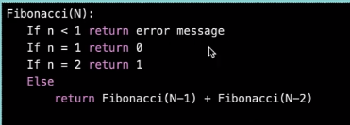

**Number factor**

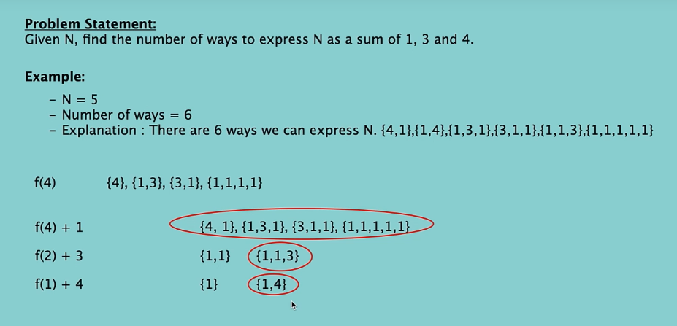

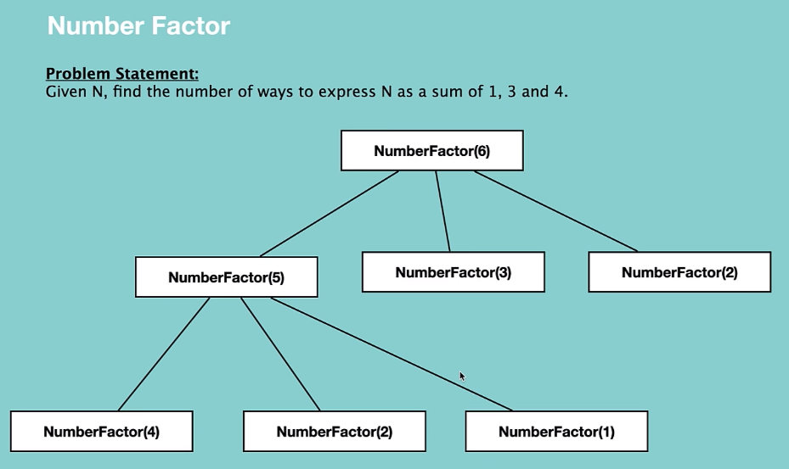

**package** DP;

**public** **class** NumberFactor {

**public** **int** waysToGetN(**int** n) {

**if**(n==0 ||n==1||n==2)

**return** 1;

**if**(n==3)

**return** 2;

**int** sub1= waysToGetN(n-1);

**int** sub2= waysToGetN(n-3);

**int** sub3= waysToGetN(n-4);

**return** sub1+sub2+sub3;

}

}

**House robber**

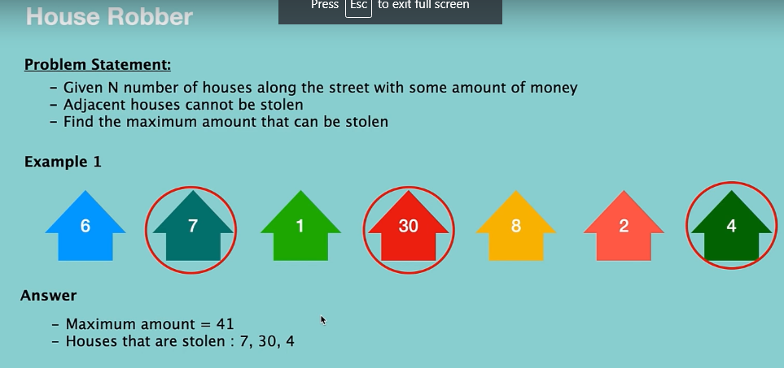



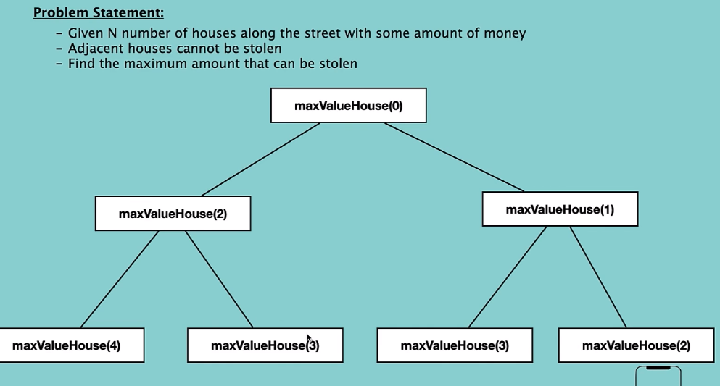

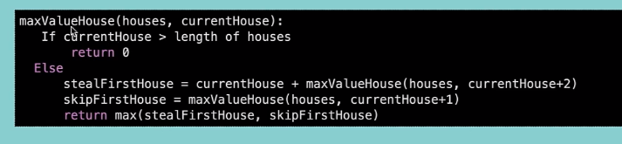

**Coding**

**package** DP;

**public** **class** HouseRobber {

**public** **static** **void** main(String args[]) {

**int**[] houseNetWorth= {6,7,1,30,8,2,4};

System.***out***.println(**new** HouseRobber().maxMoney(houseNetWorth));

}

**private** **int** maxMoneyRecursively(**int**[] houseNetWorth, **int** currentIndex) {

**if**(currentIndex>=houseNetWorth.length)

**return** 0;

**int** stealCurrentHouse= houseNetWorth[currentIndex]+maxMoneyRecursively(houseNetWorth,currentIndex+2);

**int** skipCurrentHouse= maxMoneyRecursively(houseNetWorth,currentIndex+1);

**return** Math.*max*(stealCurrentHouse, skipCurrentHouse);

}

**public** **int** maxMoney(**int**[] houseNetWorth) {

**return** maxMoneyRecursively(houseNetWorth,0);

}

}

**Convert one String to another**

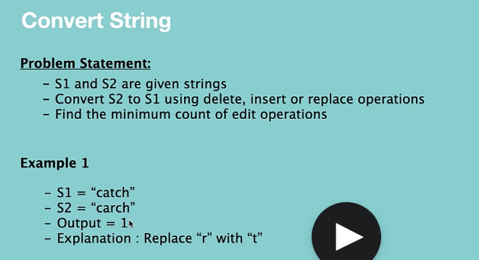

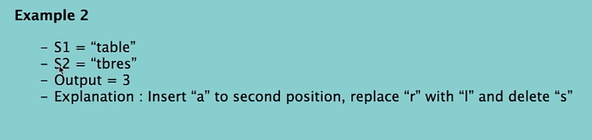

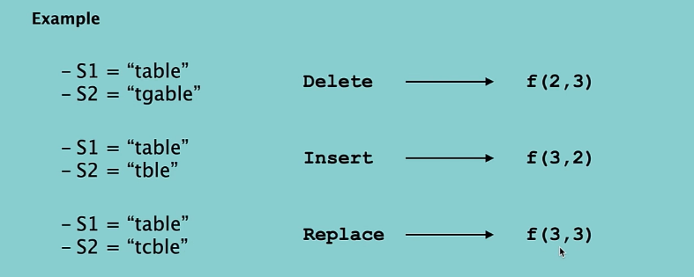

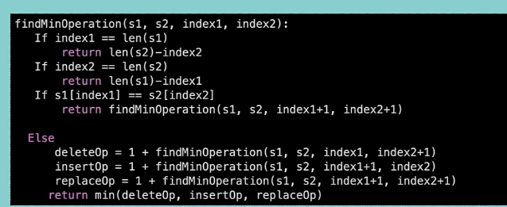

**Code:**

**package** DP;

**public** **class** ConvertOneStringToAnother {

**public** **static** **void** main(String args[]) {

ConvertOneStringToAnother c= **new** ConvertOneStringToAnother();

**int** res=c.findMinOperations("table", "tbres");

System.***out***.println(res);

}

**private** **int** findMinOperations(String s1, String s2, **int** i1,**int** i2) {

**if**(i1==s1.length())

**return** s2.length()-i2;

**if**(i2==s2.length())

**return** s1.length()-i1;

**if**(s1.charAt(i1)==s2.charAt(i2))

**return** findMinOperations(s1,s2,i1+1,i2+1);

**int** deleteOp=1+findMinOperations(s1,s2,i1,i2+1);

**int** insertOp=1+findMinOperations(s1,s2,i1+1,i2);

**int** replaceOp=1+findMinOperations(s1,s2,i1+1,i2+1);

**return** Math.*min*(deleteOp,Math.*min*(insertOp, replaceOp));

}

**public** **int** findMinOperations(String s1, String s2) {

**return** findMinOperations(s1,s2,0,0);

}

}

**Zero One Knapsack problem**

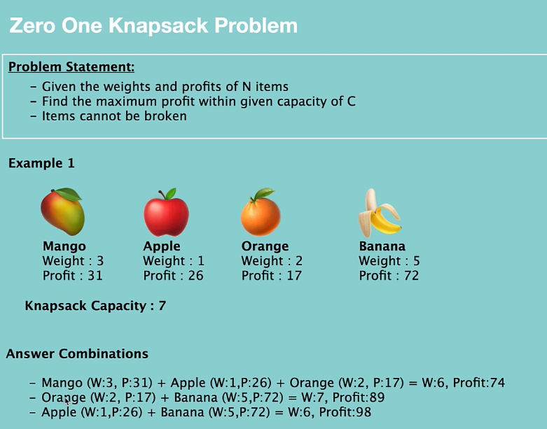

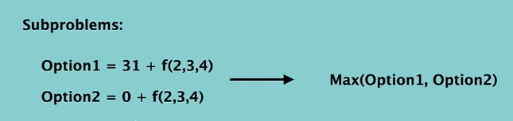

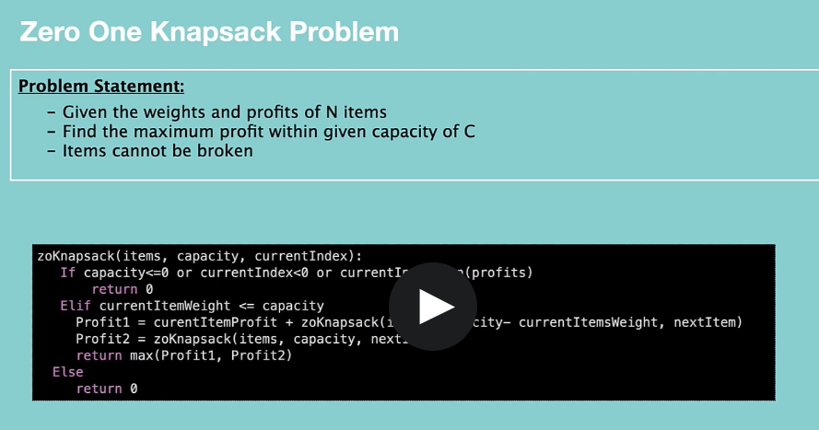

**public** **class** ZeroOneKnapsack {

**private** **int** knapsack(**int**[] profits, **int**[] weights, **int** capacity, **int** currentIndex) {

**if**(capacity<=0 || currentIndex>=profits.length || currentIndex<0) {

**return** 0;

}

**int** profit1=0,profit2=0;

**if**(weights[currentIndex]<=capacity) {

profit1= profits[currentIndex]+knapsack(profits,weights,capacity-weights[currentIndex]

,currentIndex+1);

}

profit2=knapsack(profits,weights,capacity,currentIndex+1);

**return** Math.*max*(profit1, profit2);

}

**public** **int** knapsack(**int**[] profits, **int**[] weights, **int** capacity) {

**return** knapsack(profits,weights,capacity,0);

}

}

**Longest common sub sequence**

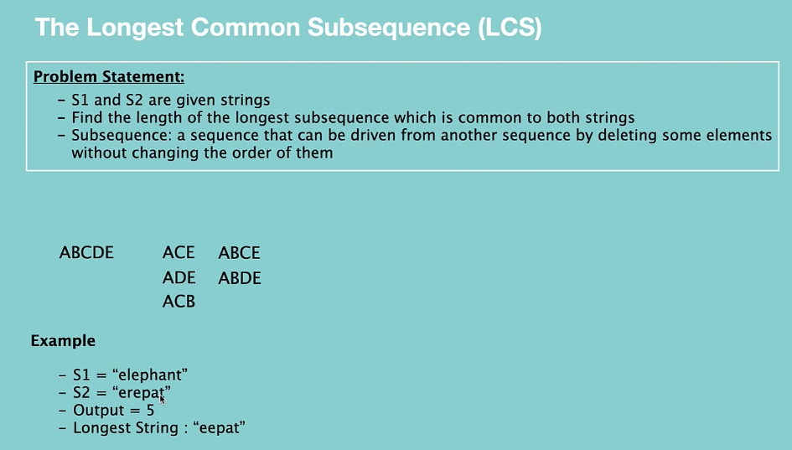

* 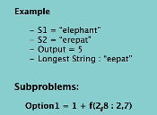

**“e” is matching. So, take the first** element and continue to check 2nd element of both the Strings.

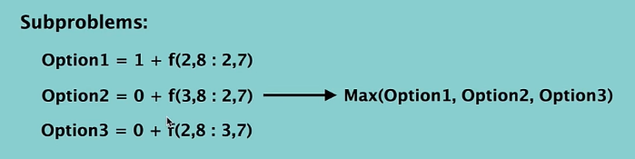

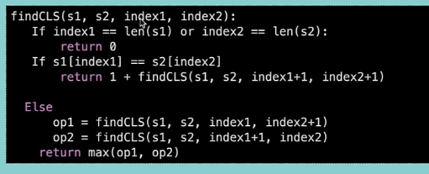

**Coding**

**public** **class** LongestCommonSubsequence {

**private** **int** LCSlength(String s1, String s2, **int** i1,**int** i2) {

**if**(i1==s1.length()||i2==s2.length())

**return** 0;

**int** c1=0;

**if**(s1.charAt(i1)==s2.charAt(i2)) {

c1=1+LCSlength(s1,s2,i1+1,i2+1);

}

**int** c2=LCSlength(s1,s2,i1+1,i2);

**int** c3=LCSlength(s1,s2,i1,i2+1);

**return** Math.*max*(c1,Math.*max*(c2, c3));

}

**public** **int** LCSLength(String s1,String s2) {

**return** LCSlength(s1,s2,0,0);

}

}

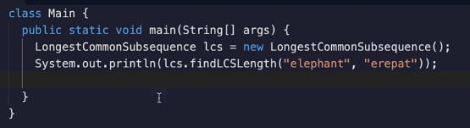

**Longest palindromic subsequence**

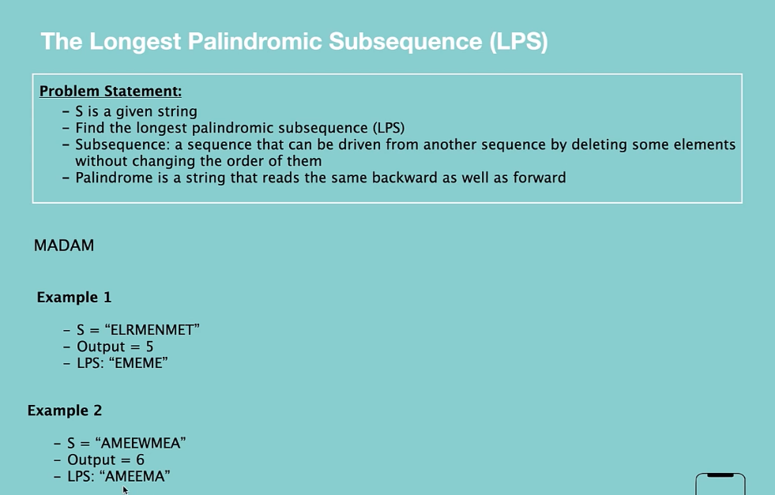

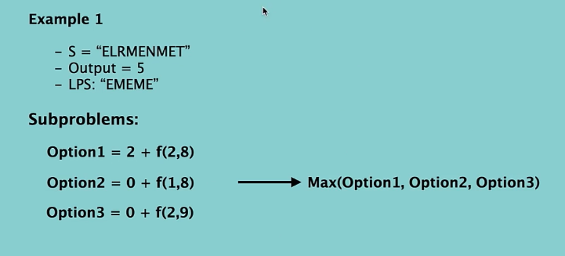

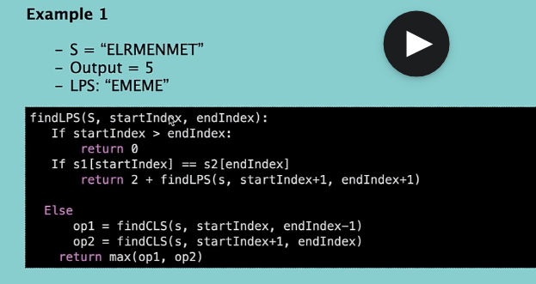

**Correction: It should be**

**Code:**

**public** **class** LongestPalindromicSubsequence {

**public** **static** **void** main(String args[]) {

LongestPalindromicSubsequence seq=**new** LongestPalindromicSubsequence();

System.***out***.println(seq.findLPSLength("elrmenmet"));

}

**private** **int** findLPS(String s, **int** startIndex, **int** endIndex) {

**if**(startIndex>endIndex) {

**return** 0;

}

**if**(startIndex==endIndex)

**return** 1;

**int** count1=0;

**if**(s.charAt(startIndex)==s.charAt(endIndex)) {

count1 = 2+ findLPS(s,startIndex+1,endIndex-1);

}

**int** count2= findLPS(s,startIndex+1,endIndex);

**int** count3= findLPS(s,startIndex,endIndex-1);

**return** Math.*max*(count1, Math.*max*(count2, count3));

}

**public** **int** findLPSLength(String s) {

**return** findLPS(s,0,s.length()-1);

}

}

**Minimum cost to reach last cell**

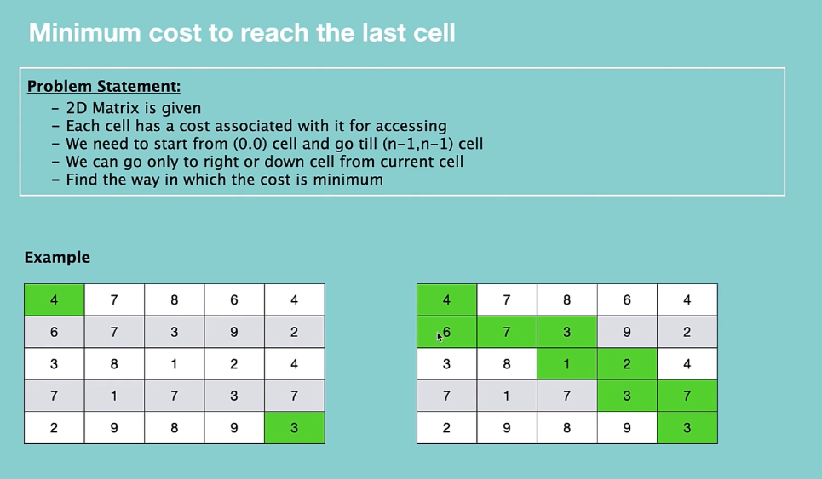

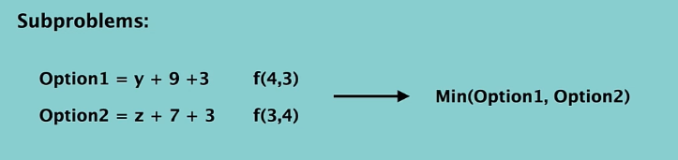

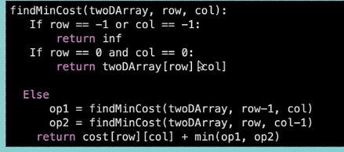

**public** **class** MinCostToReachLastCell {

**public** **static** **void** main(String args[]) {

**int**[][] array= {

{4,7,8,5,4},

{6,7,3,9,2},

{3,8,1,2,4},

{7,1,7,3,7},

{7,0,8,9,3}

};

}

**public** **int** findMinCost(**int**[][] cost, **int** row, **int** col) {

**if**(row==-1||col==-1)

**return** Integer.***MAX_VALUE***;

**if**(row==0 && col==0) {

**return** cost[row][col];

}

**int** mincost1=findMinCost(cost,row,col-1);

**int** mincost2=findMinCost(cost,row-1,col);

**int** mincost= Math.*min*(mincost1, mincost2);

**return** mincost+cost[row][col];

}

}

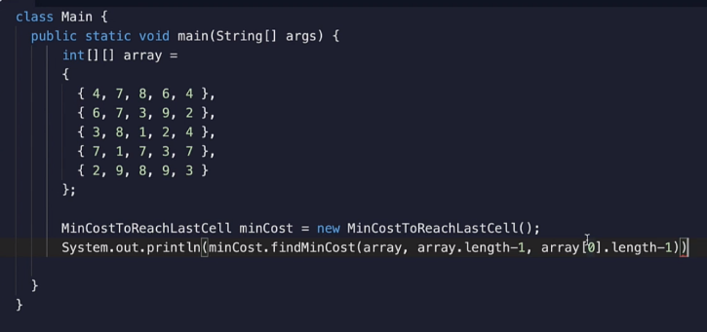

**Number of paths to reach the last cell with the given cost**

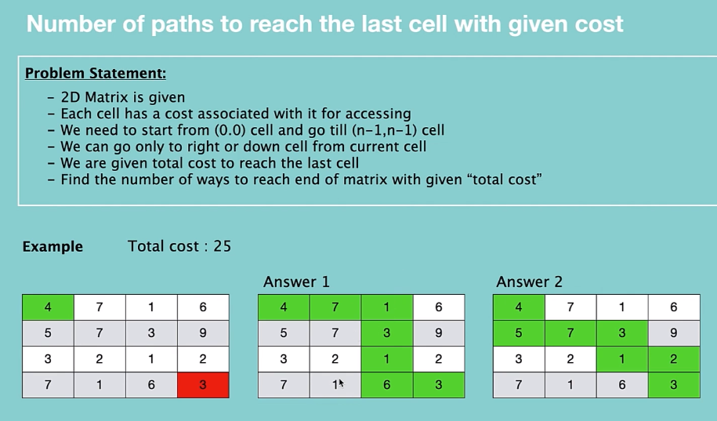

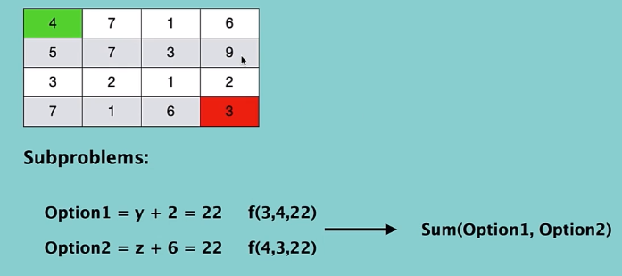

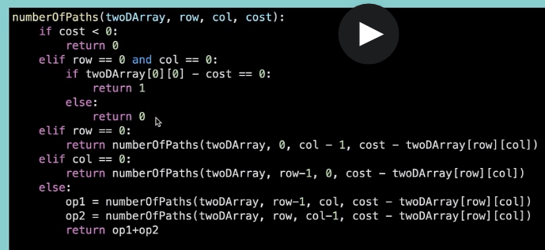

**Code:**

**public** **class** NumPathsToReachLastCell {

**public** **static** **void** main(String args[]) {

**int**[][]array= {

{4,7,1,6},

{5,7,3,9},

{3,2,1,2},

{7,1,6,3}

};

**int** cost=25;

}

**public** **int** numberOfPaths(**int**[][] array, **int** row, **int** col, **int** cost) {

**if**(cost<0)

**return** 0;

**if**(row==0 && col==0) {

**return** (array[row][col]-cost == 0)? 1:0;

}

**if**(row==0)

{

**return** numberOfPaths(array,row,col-1,cost-array[row][col]);

}

**if**(col==0) {

**return** numberOfPaths(array,row-1,col,cost-array[row][col]);

}

**int** sub1=numberOfPaths(array,row-1,col,cost-array[row][col]);

**int** sub2=numberOfPaths(array,row,col-1,cost-array[row][col]);

**return** sub1+sub2;

}

}

**Dynamic programming Continuation**

**House robber problem**

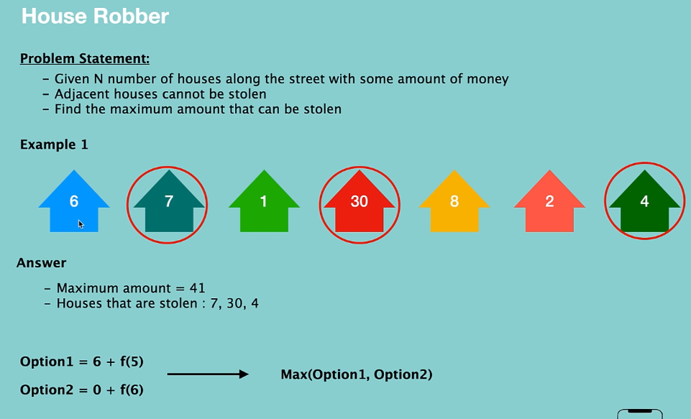

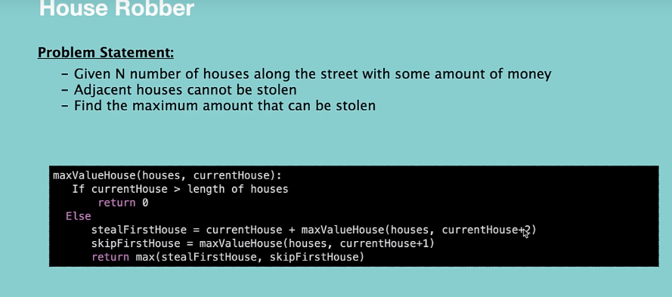

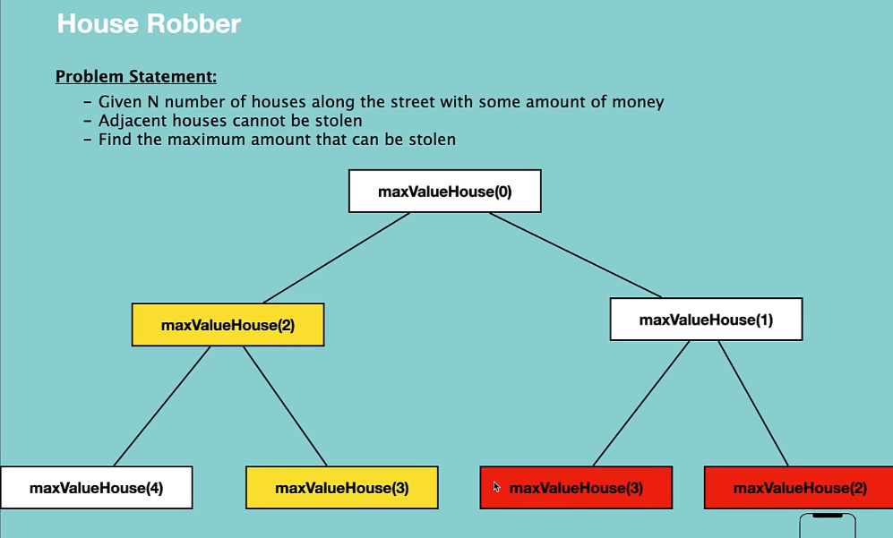

Overlapping subproblem property.

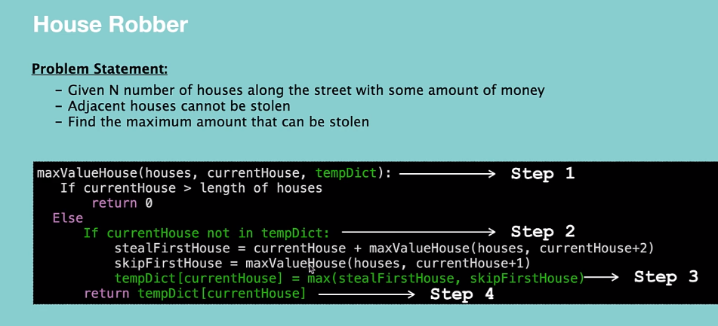

The above implementation is of top down approach.

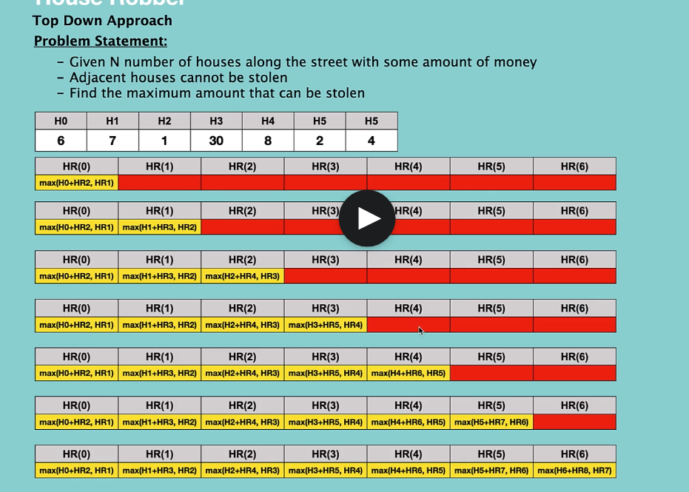

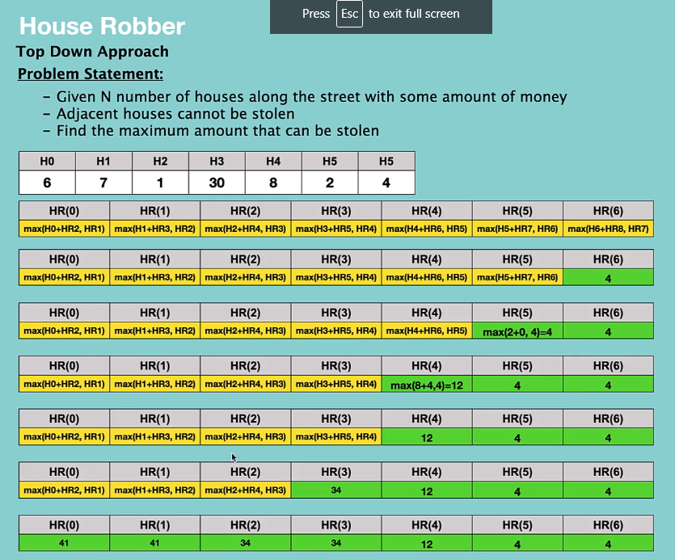

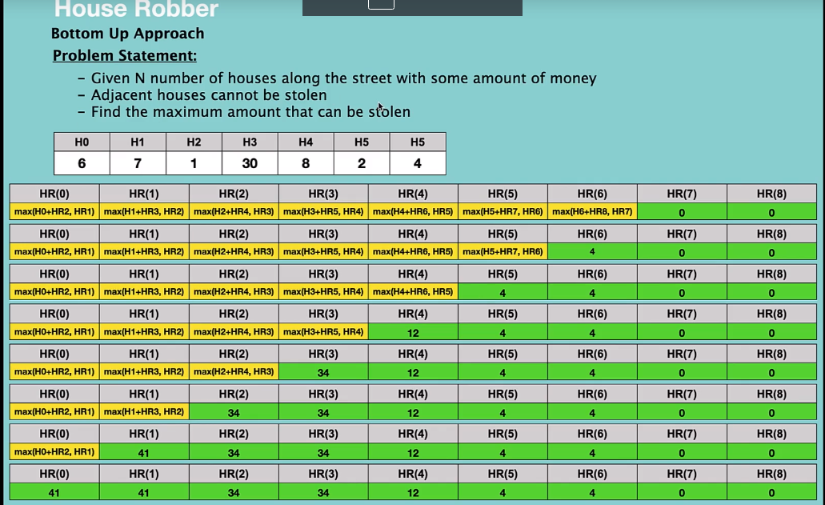

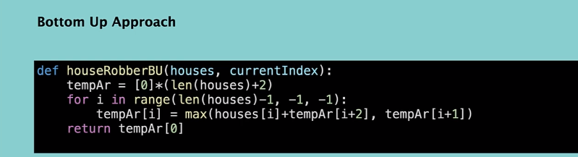

**Solution to top down and bottom up approach**

1. public class HouseRobber {
3. public int maxMoneyTopDown(int[] HouseNetWorth) {
4. int dp[] = new int[HouseNetWorth.length];
5. return maxMoneyTopDown(dp, HouseNetWorth, 0);
6. }

9. private int maxMoneyTopDown(int[] dp, int[] HouseNetWorth, int currentIndex) {
10. if (currentIndex >= HouseNetWorth.length)
11. return 0;
13. if (dp[currentIndex] == 0) {
14. int stealCurrent = HouseNetWorth[currentIndex] + maxMoneyTopDown(dp, HouseNetWorth, currentIndex + 2);
15. int skipCurrent = maxMoneyTopDown(dp, HouseNetWorth, currentIndex + 1);
16. dp[currentIndex] = Math.max(stealCurrent, skipCurrent);
17. }
18. return dp[currentIndex];
19. }
21. public int maxMoneyBottomUp(int[] wealth) {
22. int dp[] = new int[wealth.length + 2]; // '+1' to handle the zero house
23. dp[wealth.length] = 0; // if there are no houses, the thief can't steal anything
24. for (int i = wealth.length - 1; i >= 0; i--) {
25. dp[i] = Math.max(wealth[i] + dp[i + 2], dp[i + 1]);
26. }
27. return dp[0];
28. }


32. }

**Convert one String to another**

